Digital Nurture 4.0 Deep Skilling
Week 5
Creating Microservices for account and loan In this hands on exercises, we will create two microservices for a bank. One microservice for handing accounts and one for handling loans.
Each microservice will be a specific independent Spring RESTful Webservice maven project having it's own pom.xml. The only difference is that, instead of having both account and loan as a single application, it is split into two different applications. These webservices will be a simple service without any backend connectivity.

OUTCOMES
- Created two separate Spring Boot microservices — account and loan
- Assigned them different ports (8300 and 8087)
- Implemented simple GET APIs with dummy responses
- Confirmed that both services are running independently

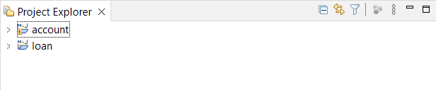

Account
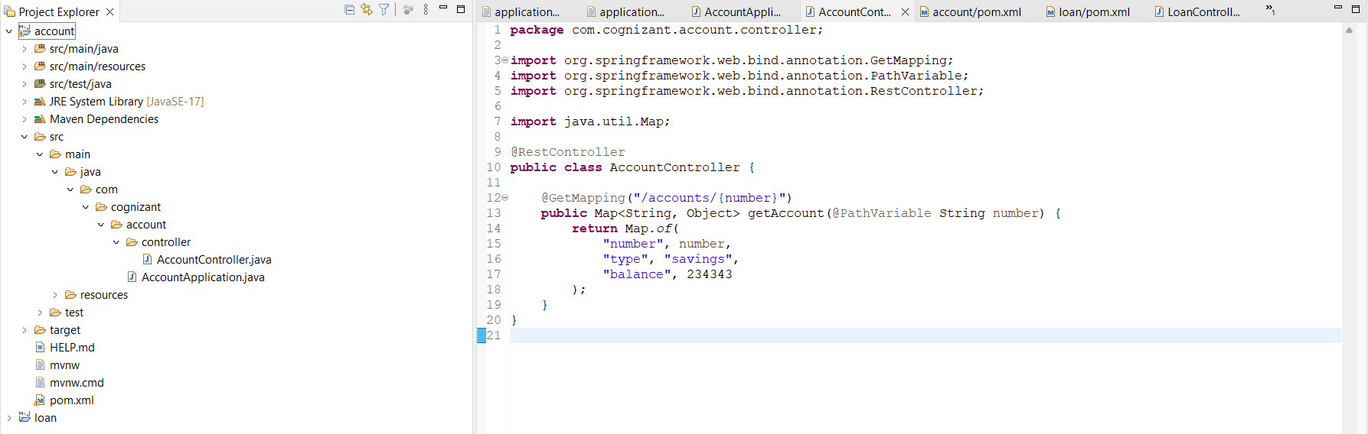

POM.XML
Dependencies
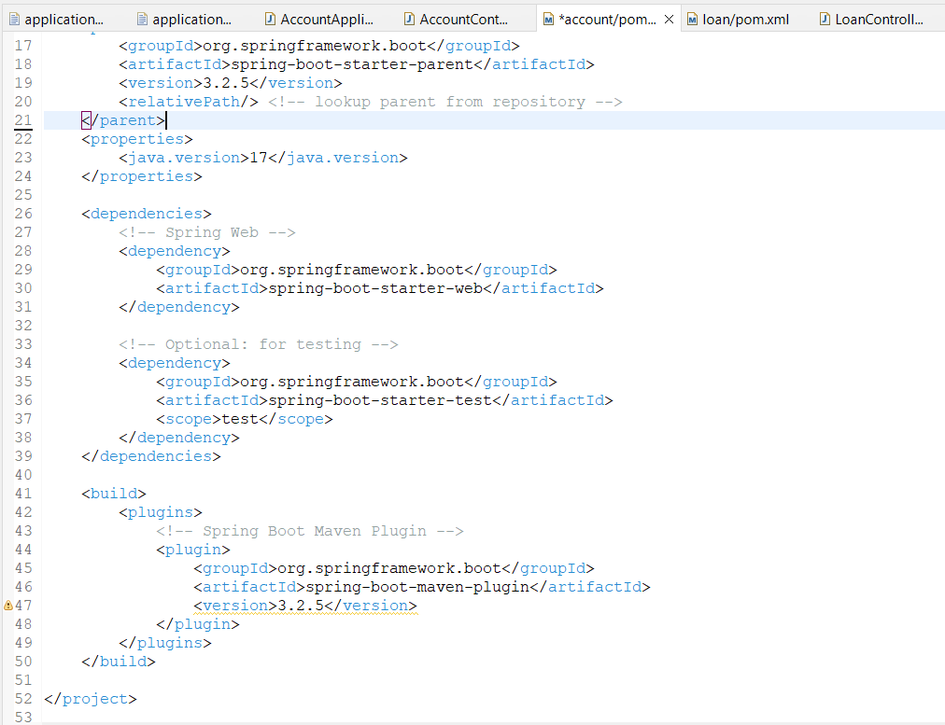

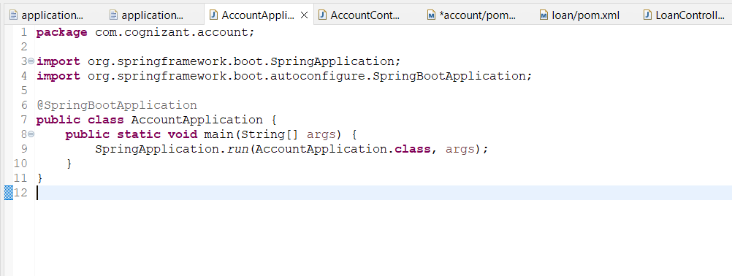
Loan
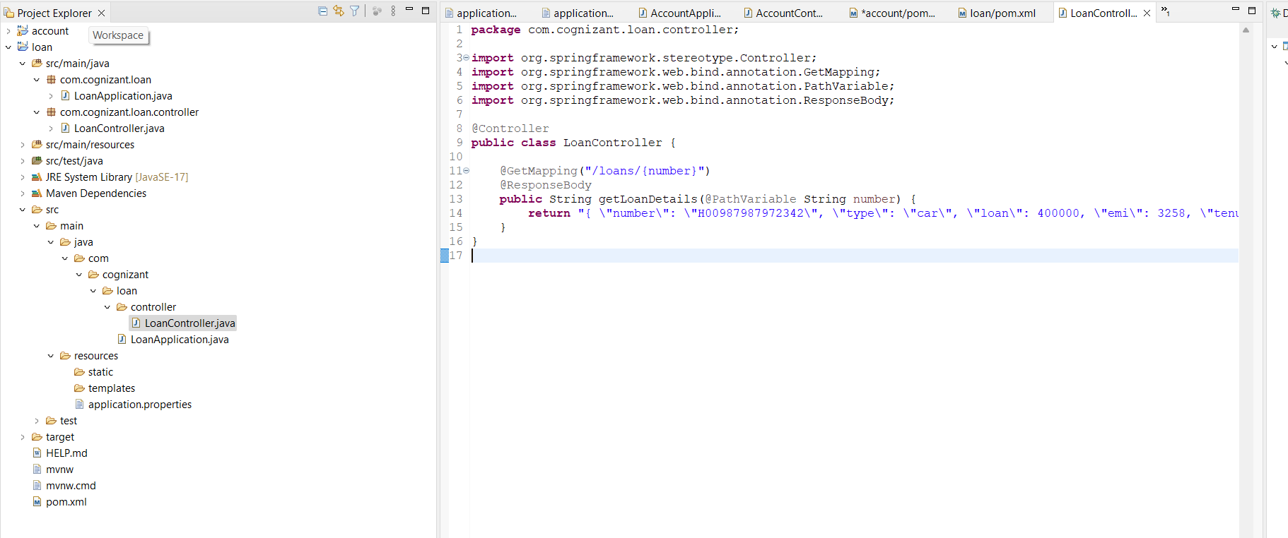
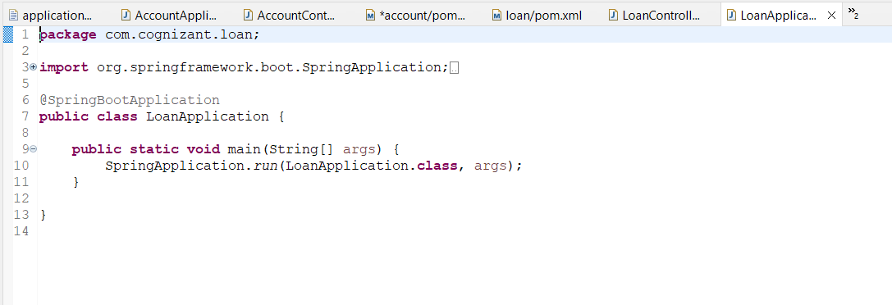

Pom.xml
Dependencies
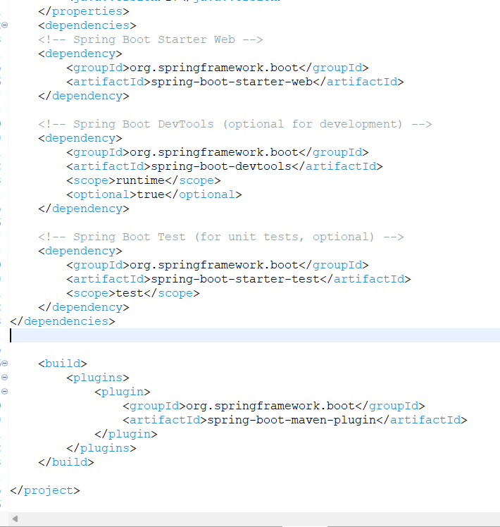

Output :
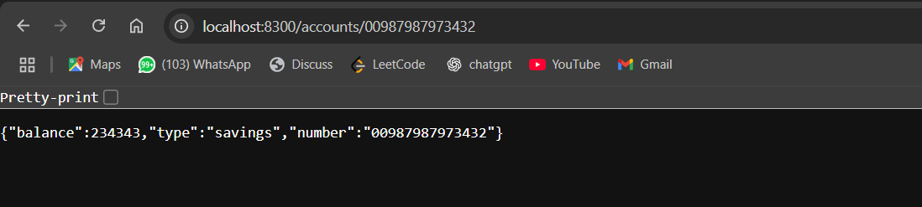
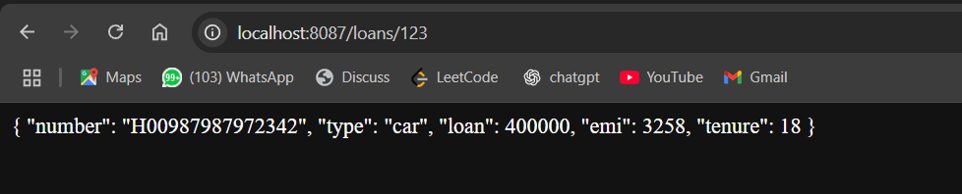
Postman :
